9427B

IT324L 1:00 – 2:30 MTh

GROUP 2

Midterm Project 1: Assigned School - STELA

Midterm Project 2: Mobile Web App (Offline) - NSTP Attendance Checker

Members:

10 EDADES, OLIZAR BRYN RIMANDO

18 MACALANDA, KENNETH NEIL MIGUEL

22 SANTOS, CHRISTOPHER PAJARILLAGA

24 ALAWAS, CRISLYN DALOG

25 CABALSE, ARIANE FAYE ESPIRITU

27 CALMERIN, KATHLEEN DUZON

30 CHU, AMARIZ JOY NG

37 HIRAI, ERIKA MAE CACHERO

39 MACARIO, MARICRIS SEGDAN

MP1 (School Website): School of Teacher Education and Liberal Arts

* CMS used: WordPress

The group used WordPress in making the CMS of the school website, as this is one of the CMS that is free and easy to use. Furthermore, WordPress is flexible with their plugins and features.

* Available Features:
* Publish with Ease – to add contents for the website with WordPress. Placing posts and pages and design them easily and showing the website on the web.
* Built-in Comments – to provide the user to add comments regarding the website or for the user to add questions about the school itself.
* Easy Theme System – to provide theme for the developers to use to make the website more presentable to the users.
* Plugin System – to provide possible extension of plugins for the website.
* Specific Features and Plug-ins used and how they were utilized in the implementation of the website
* Custom CSS – modifies predefined CSS in theme such as font size and such.
* SiteOrigin Widgets Bundle – a plugin in WordPress to attach widgets and icons.
* WP Super Cache – a plugin in WordPress that will be used for caching the website so that it can easily be loaded when it is already cached and does not necessarily fetch data from server every time site is visited.
* Envira Gallery – used to organize the images featured in the activities and events page.
* Page Builder by SiteOrigin - drag and drop page builder required to be able to use SiteOrigin widgets bundle used in the home and activities & events page.

MP2 (Offline mobile web application): NSTP Attendance Checker

* Description of the application:

The application that the group will make is to automate the attendance checker for the NSTP students. The NSTP Attendance Checker’s main performance is about the demerit and absences of the student during their NSTP time as this will give them additional hours to complete the NSTP requirements. The other feature of this application includes backups with the use of JSON to store data as this will import it into a JSON file. The interface of the application will include the class code of the class and the teacher in charge of the class, the time and days of the NSTP and the students who are in the class during those times. The main user for this application are the instructor in charge and the class staff during that time as they will check the attendance of the students and see if the student is late or absent during that day to give reports as on how many hours they need to complete the NSTP.

* Description of the existing modules and implemented functionality in these modules
* HTML – local storage for the classes and students of NSTP.
* CSS – for the design of the website
* JavaScript – store the json file to local storage and manipulate html to include the parsed of the uploaded file to choose file and drop down for the application
* Required HTML5 features that were used and how they were utilized in the submitted application
* JSON Objects – used to read files about the needed NSTP information.
* XMLHttpRequest – used in storing student information in the local storage and viewing the reports of the student regarding their demerit and absences.
* Required Field and Range Validators – validates the input of the user in the application.
* FileReader – used it to read files (eg. Student information) from the computer as a JSON data.

**MP1 SCREENSHOTS AND DESCRIPTIONS**

The **home page** contains a slider and an action button which slides down to the primary content containing a brief description of the School of Teacher Education and Liberal Arts (STELA) and additional information such as the department heads and the Kasama/SSC members of the aforementioned school. Buttons that redirects the user to pages in relation to STELA are also included.

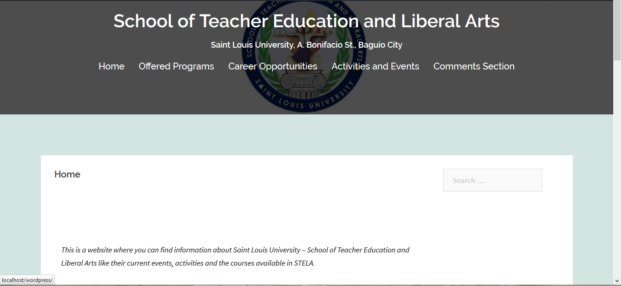

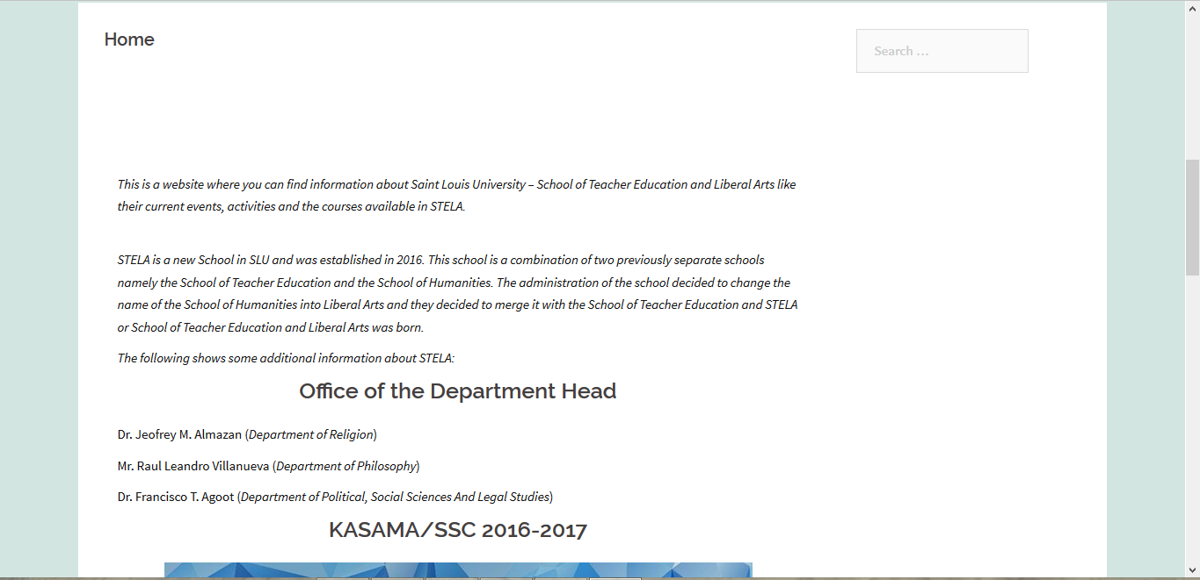



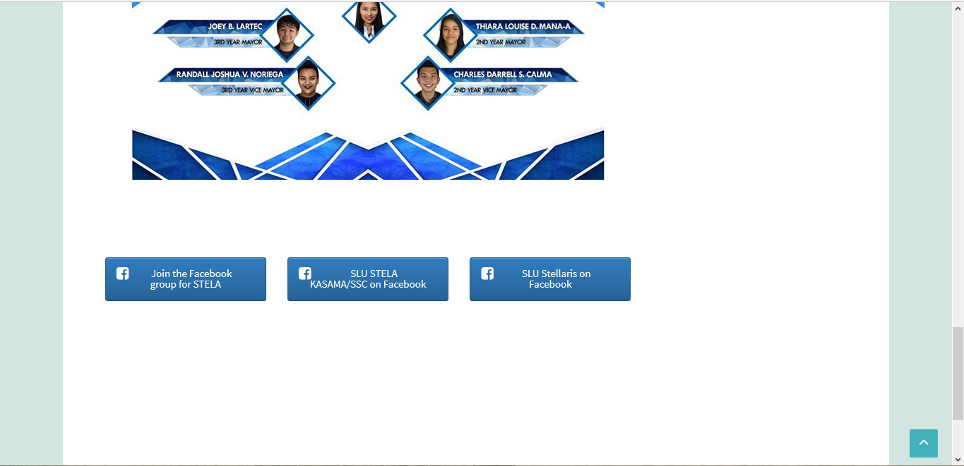

The **Offered Programs** page contains a list of the programs and their courses offered by STELA.



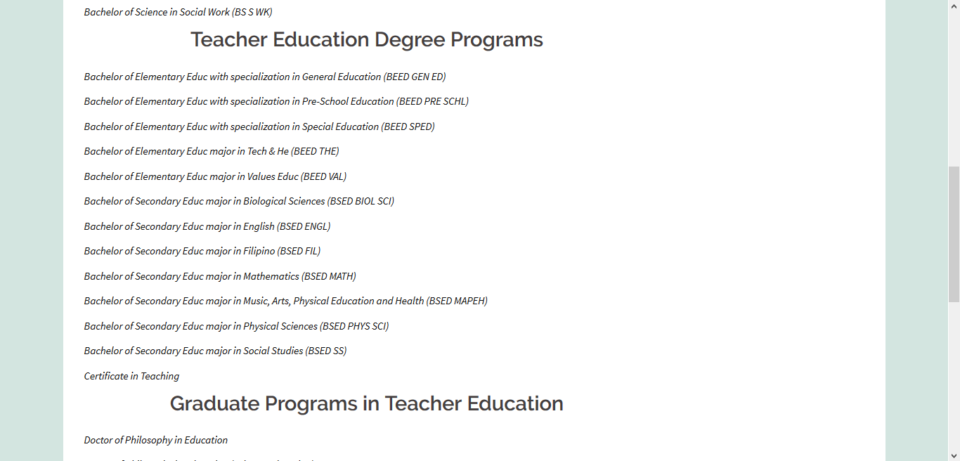

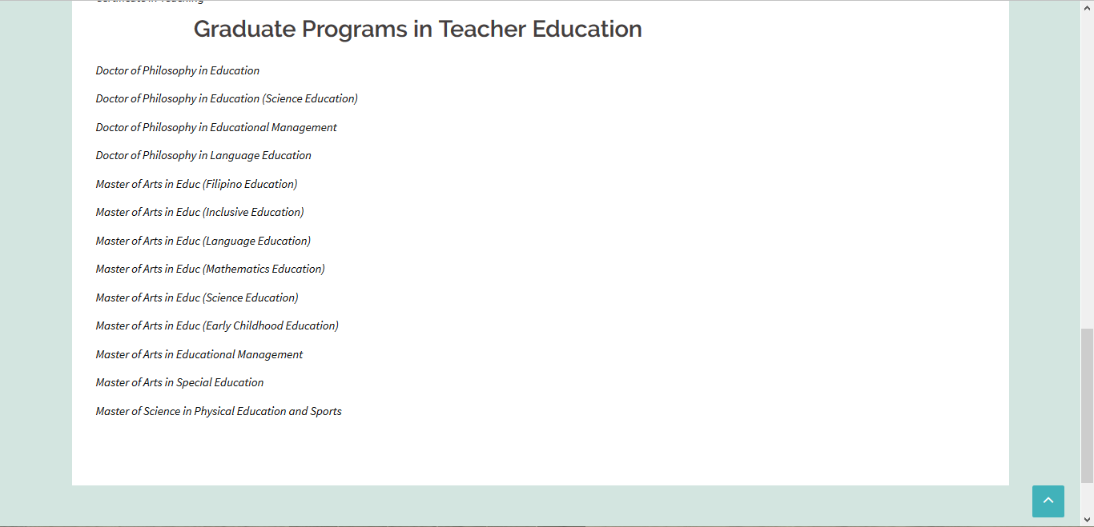

The **Career Opportunities** page consists of a list of the potential jobs that STELA graduates may get in the industry.



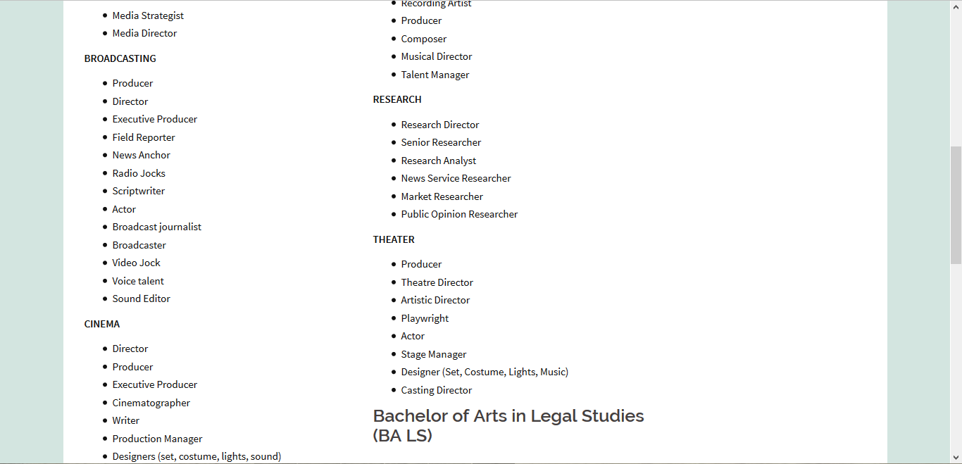

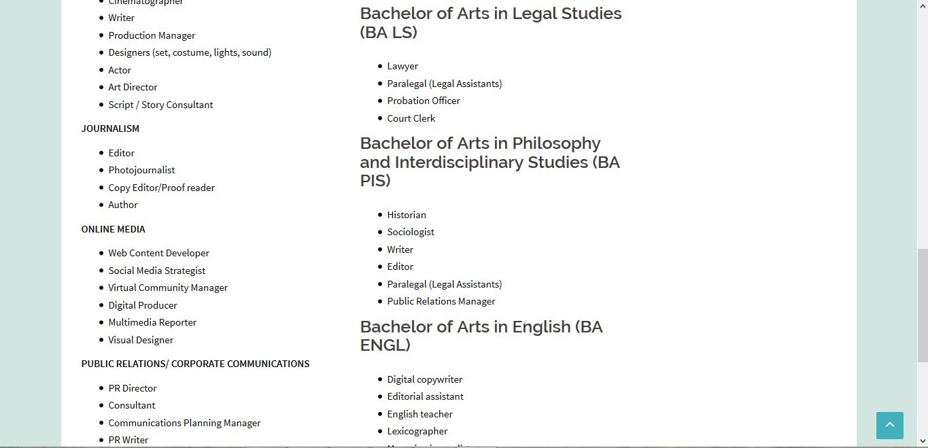

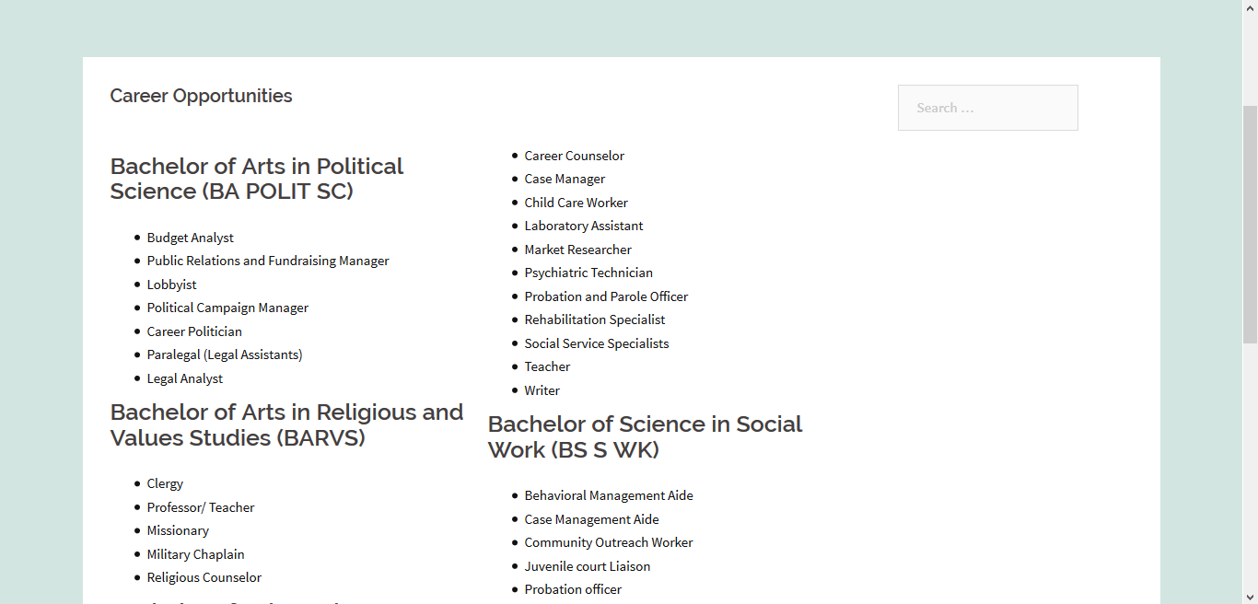

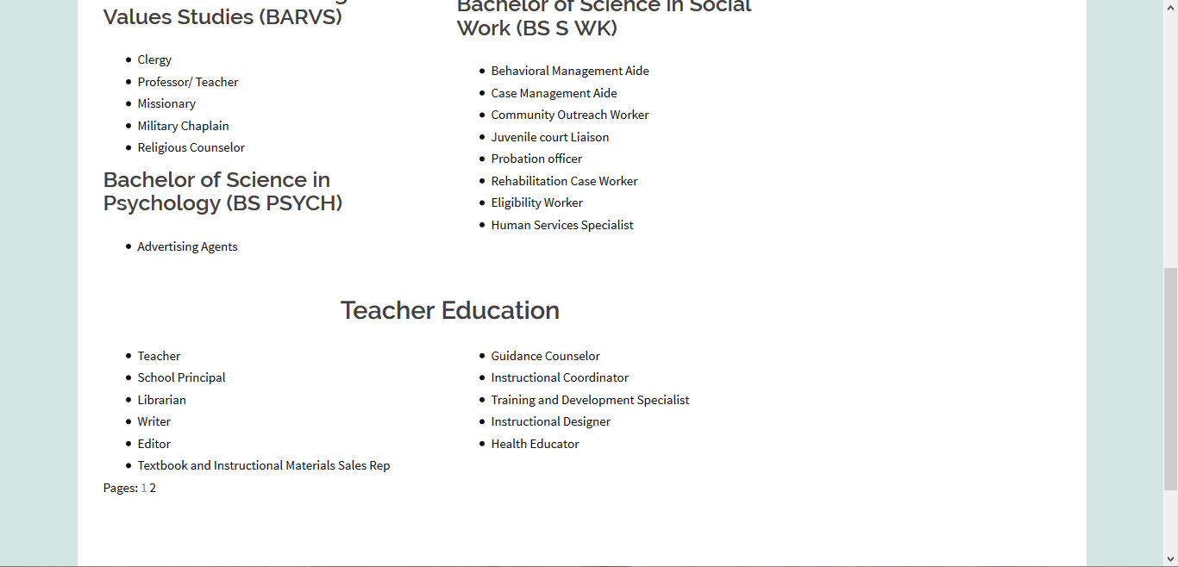

The **Activities and Events** page contains sliders and galleries containing images of the events that the STELA students participate to. A brief description of some of the events were also included. This page was made using the plugins SiteOrigin Widgets Bundle, Page Builder by SiteOrigin, and Envira Gallery (Lite).

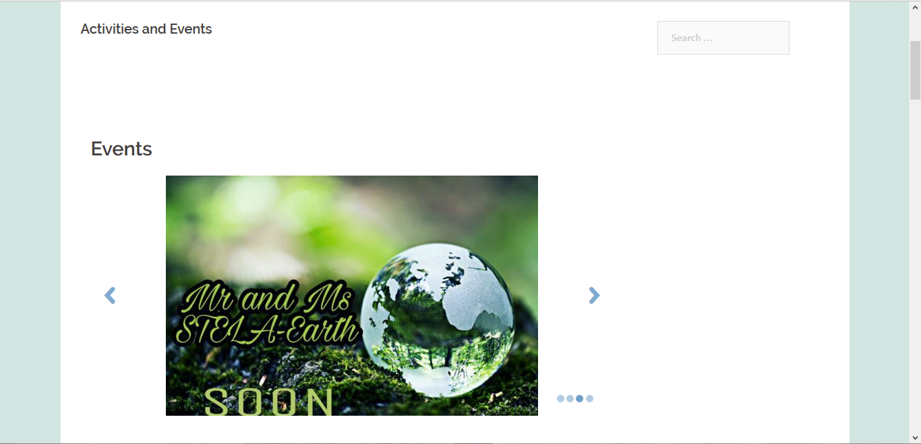

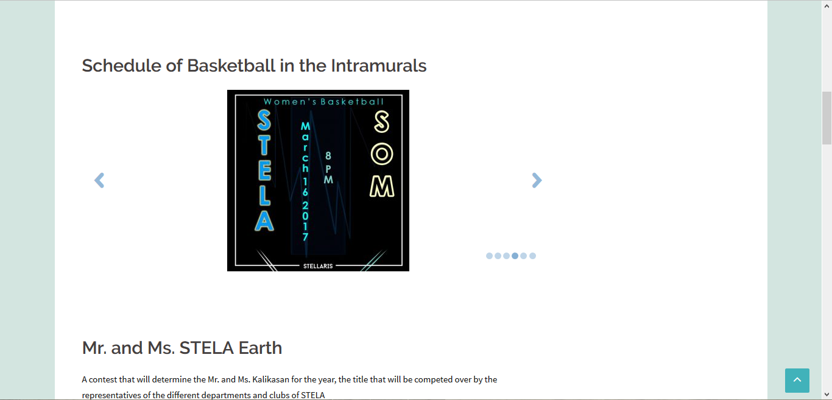

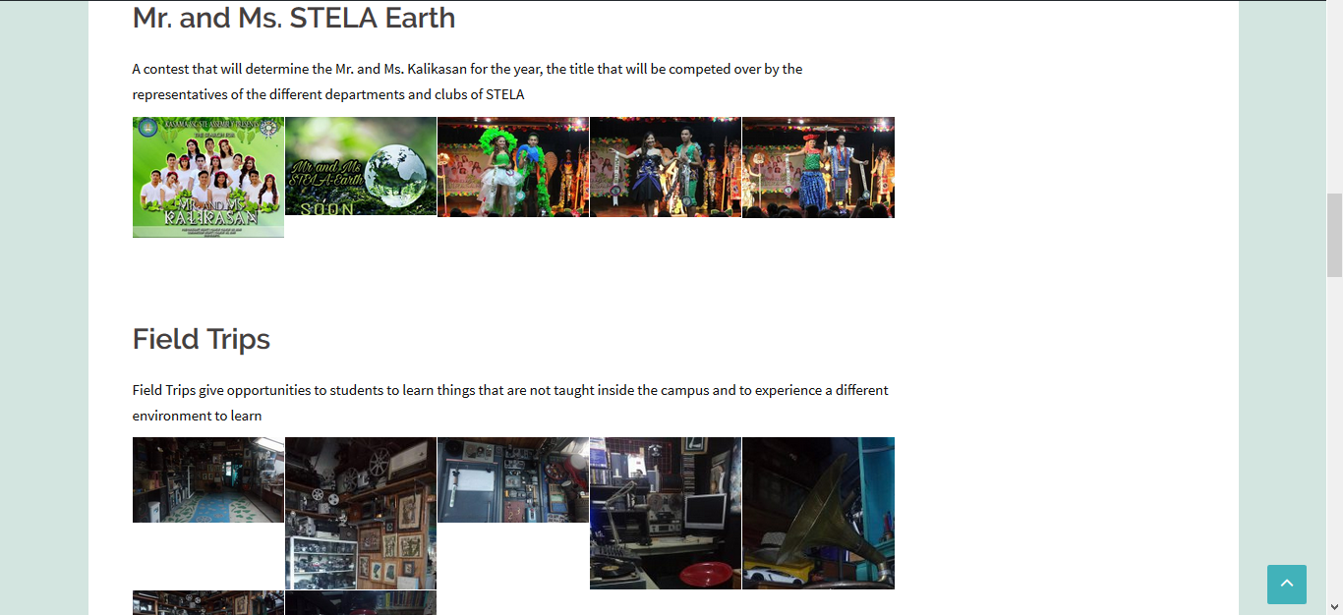

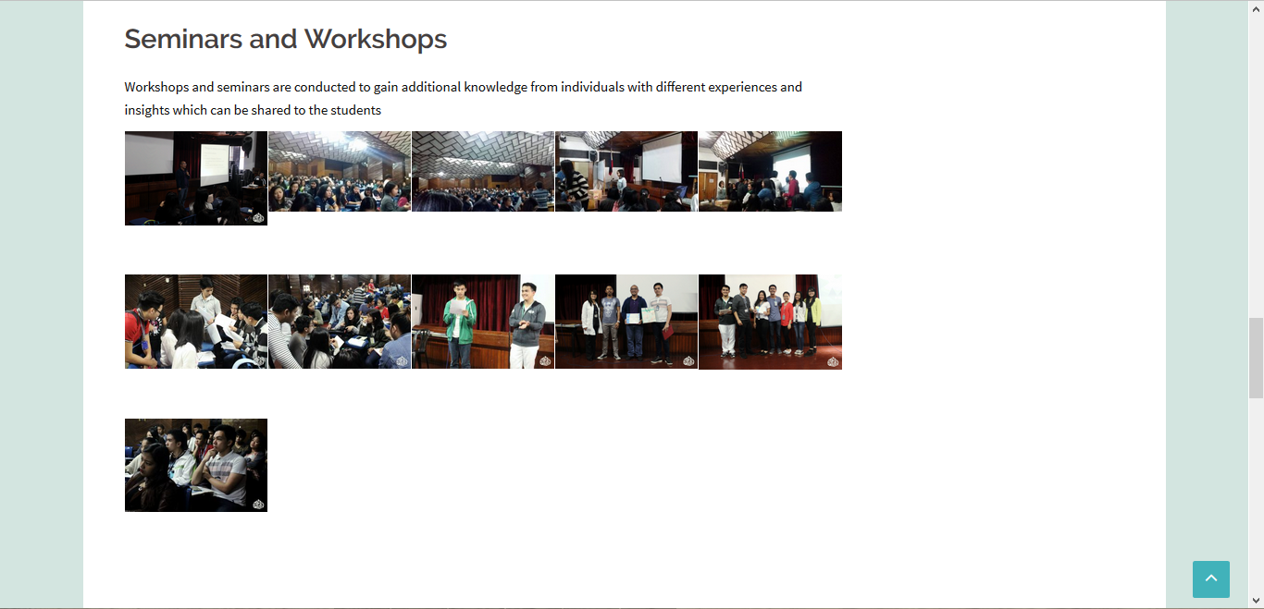

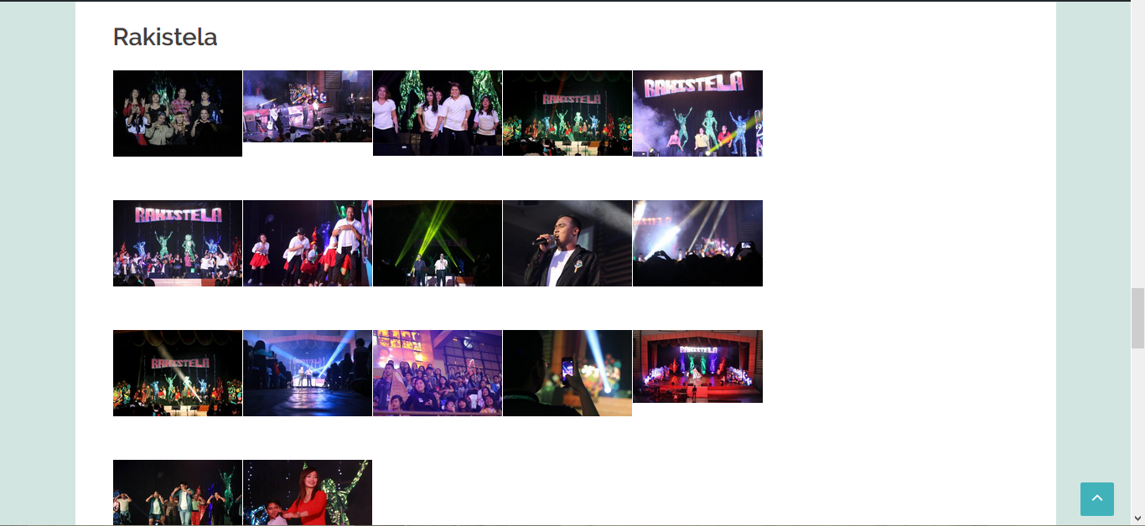

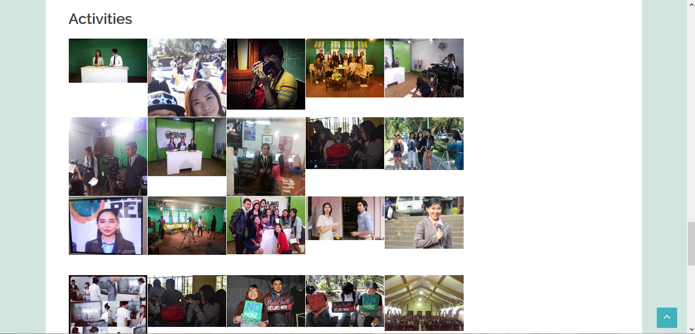

The **Comments Section** was made by creating a post in WordPress and is intended for users to write their opinions and questions regarding the school, site, and its contents.

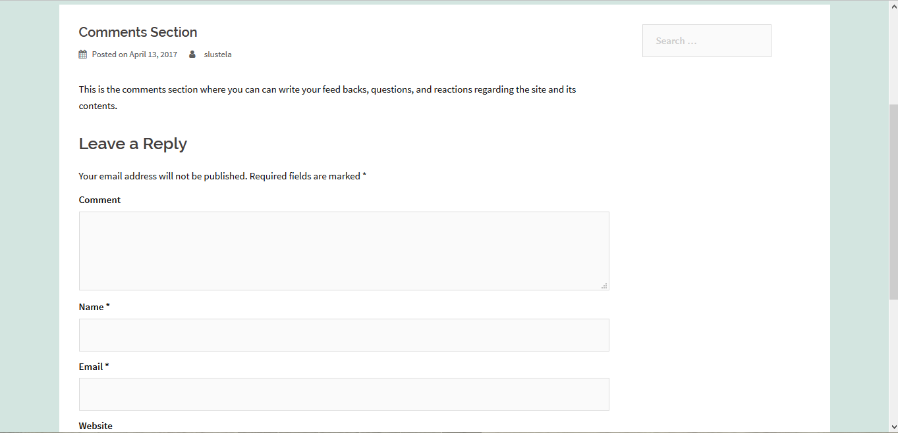



The **Developers** page features the people who contributed to the creation of the website.

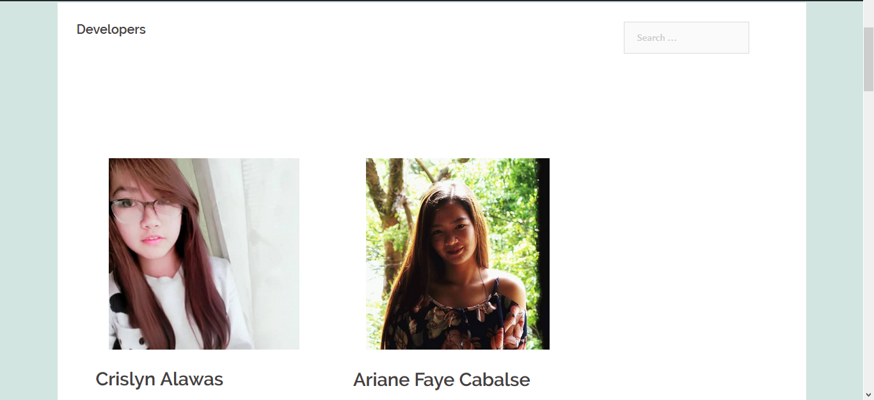

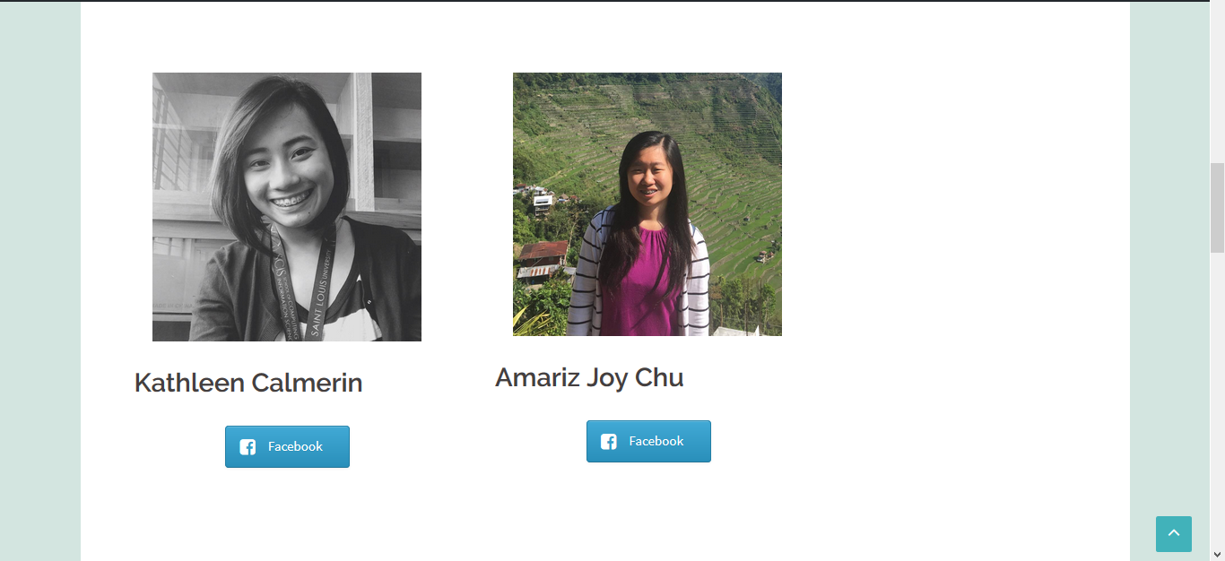

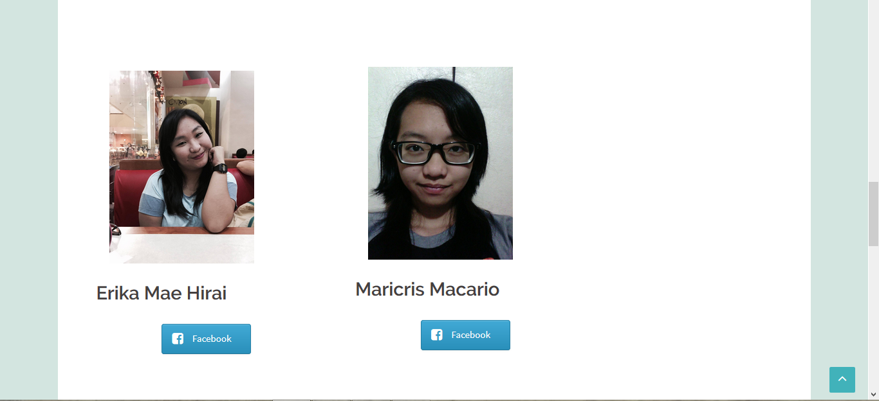

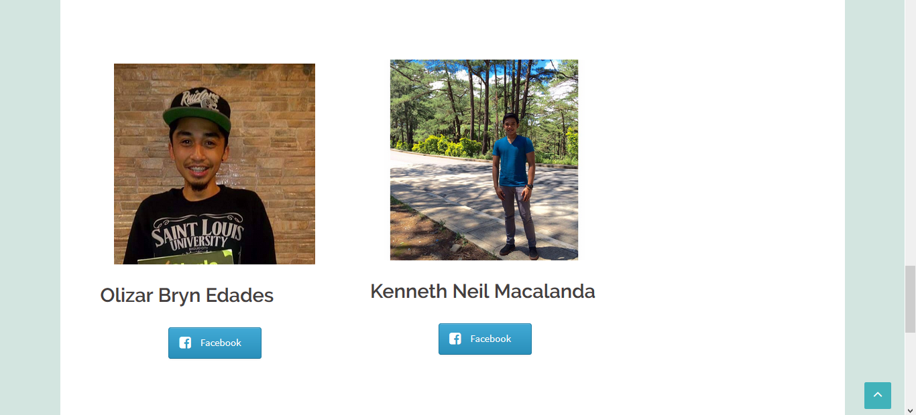

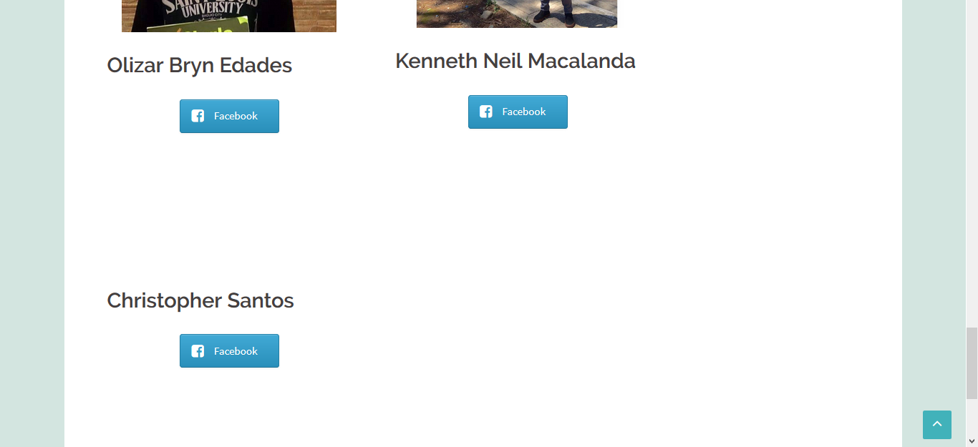

The **Event Calendar** page consists of a calendar that features the different recent and upcoming events in the school.

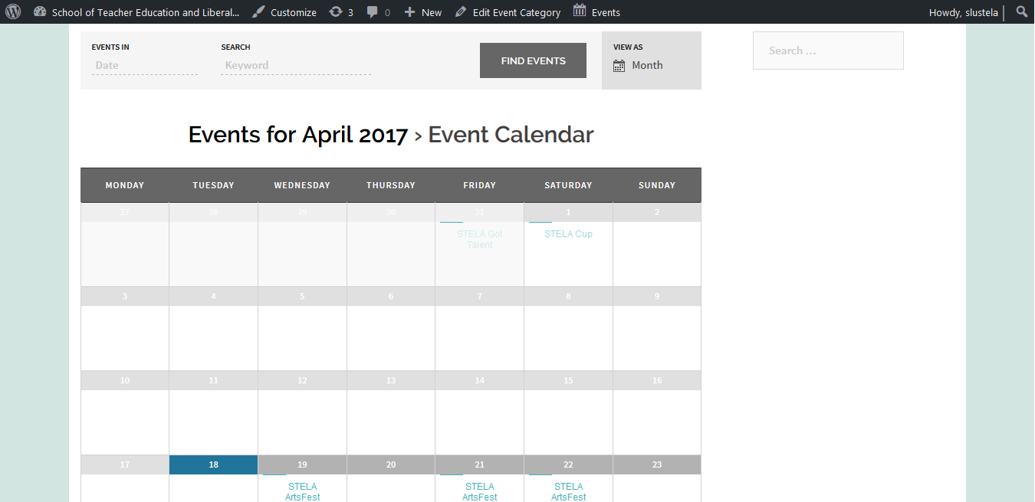

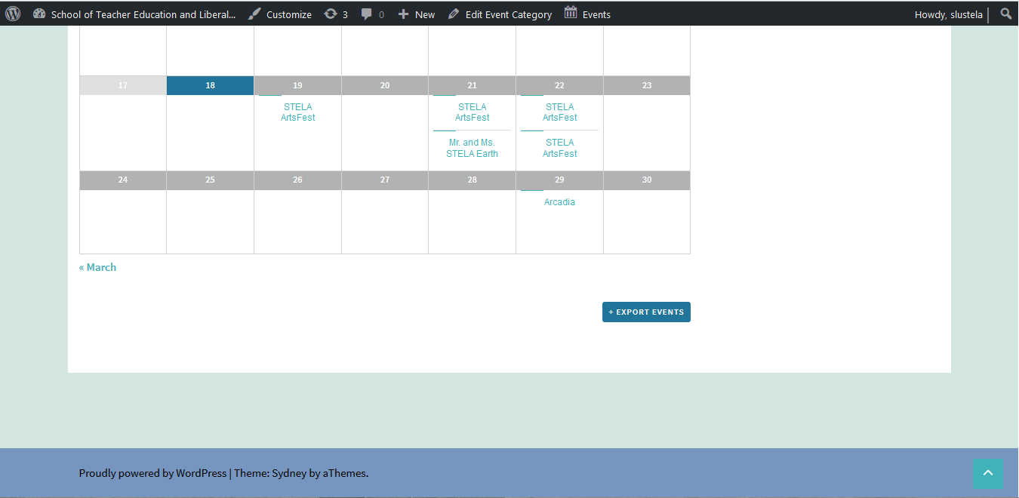

**MP2 SCREENSHOTS AND DESCRIPTIONS WITH RESONSIVE LAYOUT**

To start the attendance checker of the NSTP students, the teacher should click choose file and get the class from the server and click the NSTP Attendance Checker.

After clicking the NSTP Attendance Checker, the teacher should choose the classcode and class day the teacher should also choose the class hour of the students that he/she wants to check.





The student list during the classcode, class day and class hour that is chosen will be pop out and the teacher can check the attendance of the student if the student is late for demerit or absent during that day.

If the student is late, the teacher can choose in the drop down to specify the late of the student.

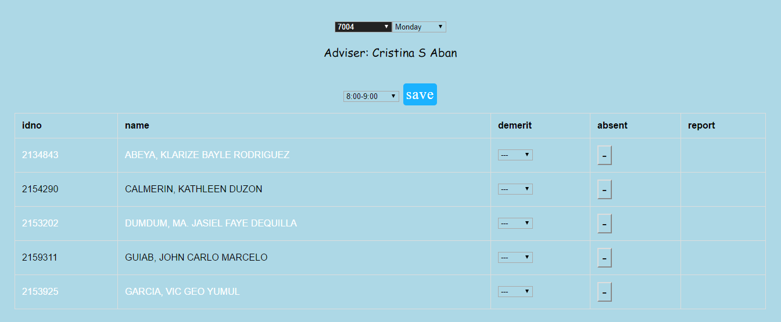

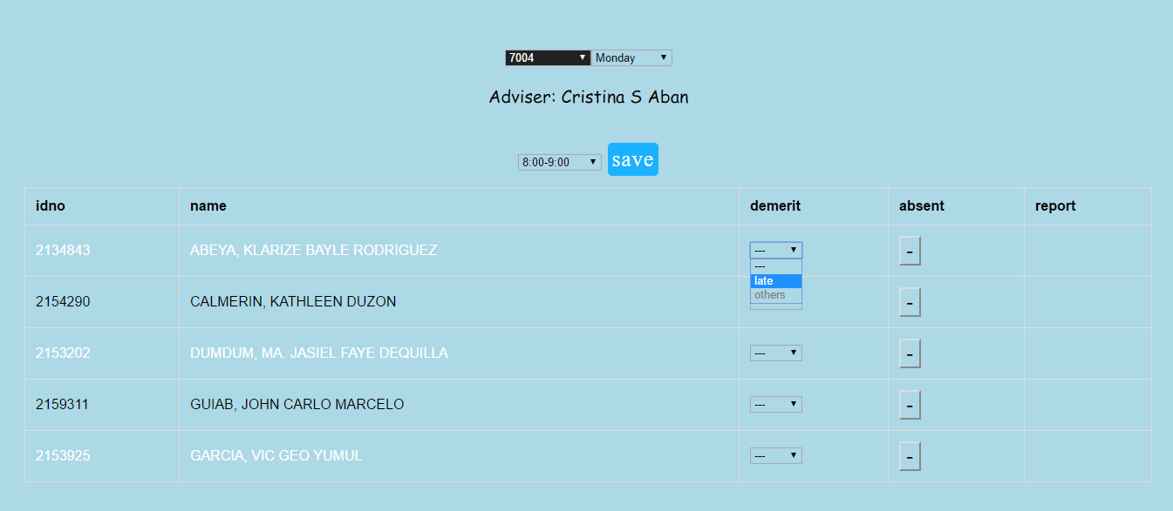

After which a screen will pop out to specify how many minutes the student is late then click confirm.

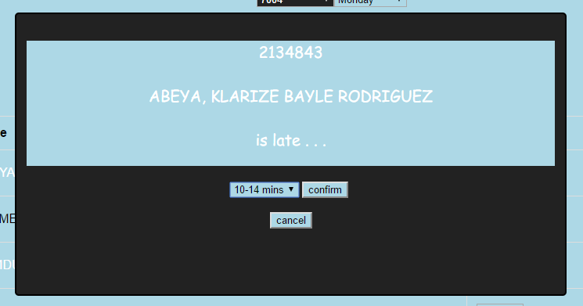

Then the points deducted to the student if he/she is late will be shown in the table of demerit and a report will be generated. As well as if the student is absent, the teacher will just click on the button and a report will be generated as well.

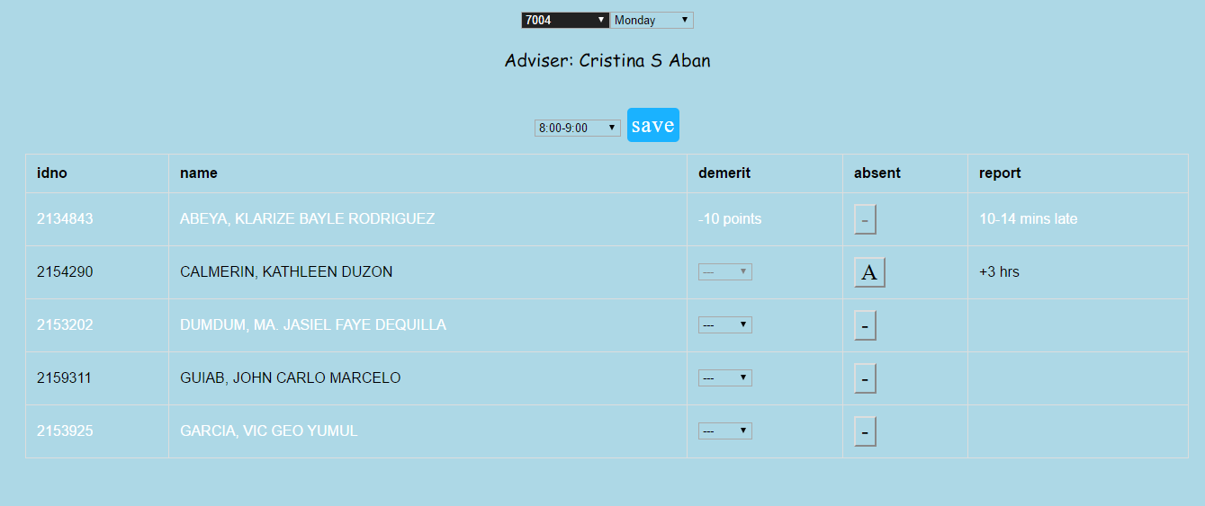

The teacher can save the attendance for the day if he/she is finish checking the attendance and the attendance of the student will be saved.

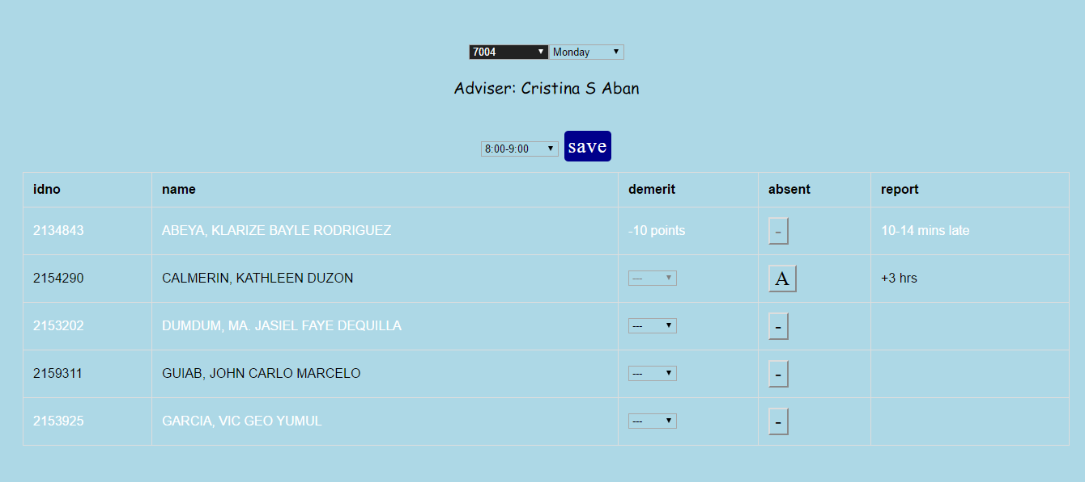

**COMMIT HISTORY**

